Flash / Solid State Devices

How do they work?
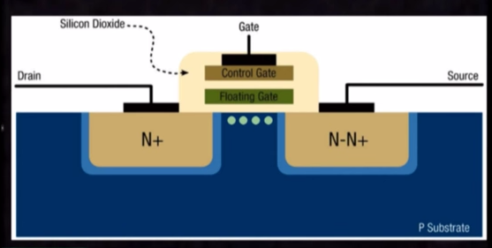
Solid state drives work by storing data inside of silicon chips, in the form of electrical charge.
The data is stored in individual memory cells, and each cell contains one transistor called a Floating Gate Transistor. This float gate transistor has the capacity to store electrons, and it is this ability to store electrons that makes it possible to store binary data.

Storing Data
In order to store data in a cell a charge is applied to the source and the large voltage difference between the source and the drain causes electrons to bump on to the floating gate and remain there. Since the electrons can only move why a high voltage is applied, when power is switched off, the electrons remain fixed to the floating gate. This is what makes Flash memory non-volatile.

Reading Data
The number of electrons attached to the floating gate affects the voltage across the control gate and it is this voltage that is measured to determine whether a value of 1 or 0 is stored. A high number of electrons means a high voltage and this is recorded as a 1. A low number of electrons means a low voltage and this is recorded as a 0.

Erasing Data
In order to erase data the polarity of the source is reversed and this causes electrons to flow off the floating gate, reducing the measured voltage and returning the value to 0.

What are they used for?
SSDs are widely used in mobile devices such as phones, tablet PC’s and netbooks. A high number of PC’s and Laptops now use Solid State Drives due to how fast and efficient they work.

Advantages
- They are very shock resistant as they have no moving parts.
- The have a high speed, making them useful for gaming pcs.
- The have a high energy efficiency, making them useful for mobile phones and other portable devices.

Disadvantages
- At present they have a limited life span, due to cell failure.
- They are more expensive than traditional hard drives.

