Optical Storage Devices

How do they work?
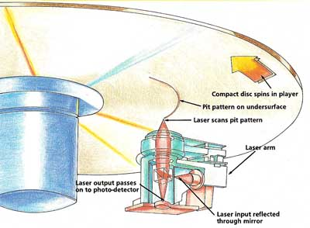

Optical storage devices work by beaming a laser at the surface a plastic disc, which reflects the light beam on to a photo-detector. On the surface of the plastic are bumps (see the picture to the right) and as the laser hits a bump the light is deflected away from the photo detector.

The photo detector is constantly detecting whether or not light is hitting it and the value stored is 0 for a hit and 1 for a miss. These 1s and 0s make up the stream of binary data that is sent to the CPU (e.g. 10110100101011011001101)

CD vs DVD vs BluRay
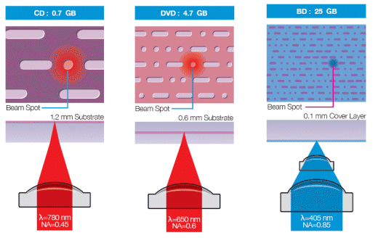
The different technologies use a different radius of laser beam, which results in different storage capacities. The smaller the radius of the laser beam, the data per disk that can be stored. Also some disks store data on more than one layer, allowing for double the storage capacity.

Pros and Cons of Optical Storage

Advantages
1. It has a mass storage capacity this is good because this allows a large amount of data on the optical device e.g. movies,
2. Countable/ uncountable storage units,
3. High data stability.

Disadvantages
1. Easily broken,
2. Require special drive to read and write,
3. It is also very expensive.

